**WEB DEVLOPMENT ASSIGNMENT - 5**

Name : Ashutosh Farswan

Roll: 20

Section: DS

Q1. Write a JavaScript function to chop a string into chunks of a given length

Test Data :  
console.log(string_chop('welcome'));  
console.log(string_chop('welcome',2));  
console.log(string_chop('welcome',3));  
["welcome"]  
["we", "lc", "om", "e"]  
["wel", "com", "e"]

<!DOCTYPE html>

<html>

<body>

<script>

function string_chop(str,l=0){

const ar = [];

if(l==0){

ar.push(str);

}

else{

for(var i=0;i<str.length;i+=l){

var s = str.substr(i,l);

ar.push(s);

}

}

return ar;

}

console.log(string_chop('welcome'));

console.log(string_chop('welcome',2));

console.log(string_chop('welcome',3));

</script>

</body>

</html>

**Output:**

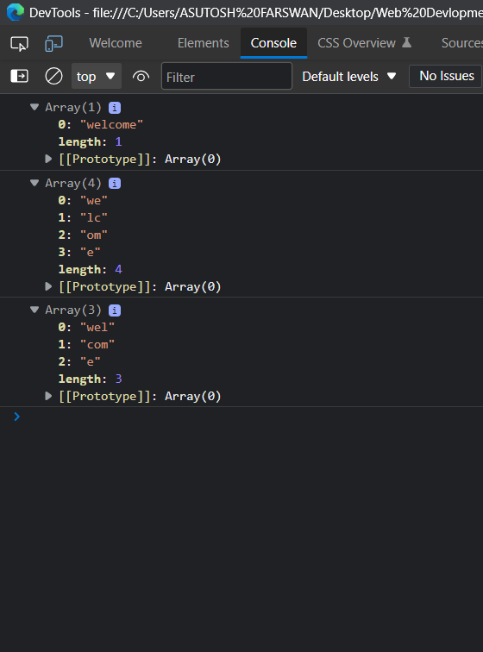

Q2. Write a JavaScript function to convert a string to title case.

Test Data :  
console.log(sentenceCase('hoW aRe YOU'));  
"How Are You"

<!DOCTYPE html>

<html>

<body>

<script>

function titleCase(str) {

str = str.toLowerCase().split(' ');

for (var i = 0; i < str.length; i++) {

str[i] = str[i].charAt(0).toUpperCase() + str[i].slice(1);

}

return str.join(' ');

}

console.log(titleCase('hoW aRe YOU'));

</script>

</body>

</html>

**OUTPUT:**

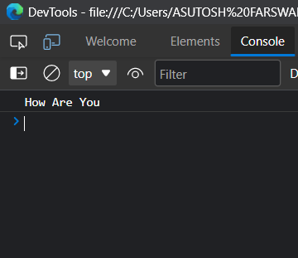

Q3. Evil Number.

<!DOCTYPE html>

<html>

<body>

<script>

function count_one(n){

let c_one = 0;

while (n != 0){

let rem = n % 10;

if (rem == 1)

c_one = c_one + 1;

n = parseInt(n / 10, 10);

}

return c_one;

}

function checkEvil(num){

var n = num;

if(n<2 || n>100){

return("Input: "+ num

+"\nNumber Out of Range.")

}

let i = 0, bin = 0, n_one = 0;

while (n != 0){

let r = n % 2;

bin = bin + r * (Math.pow(10, i));

n = parseInt(n / 2, 10);

i++;

}

n_one = count_one(bin);

if (n_one % 2 == 0){

return("Input: "+ num

+"\nBinary Equivalent: "+bin

+"\nNumber of 1's: "

+n_one+"\nEvil Number.");

}

else{

return("Input: "+ num

+"\nBinary Equivalent: "+bin

+"\nNumber of 1's: "+n_one

+"\nNot Evil Number.");

}

}

console.log(checkEvil(15));

console.log(checkEvil(26));

console.log(checkEvil(145));

</script>

</body>

</html>

**OUTPUT:**

